**Software Process Selection and Project Plan**

**P07:Hitcherr**

|  |  |
| --- | --- |
| **Student ID** | **Name** |
| **23100040** | **Mustafa Afzal** |
| **22100021** | **M Muneeb Arshad** |
| **23100333** | **Nashrah Shaukat** |
| **23100020** | **Ebad Ur Rehman** |
| **23100337** | **Irtza Tariq** |

**Table of Contents**

1. Introduction 3

2. Software Process Selection 4

3. Gantt Chart 5

4. Risk Management 5

4.1 Potential Risks and Mitigation Strategies 5

5. Development Environment Preparation 6

6. Deployment Platform 6

7. Who Did What? 7

8. Review checklist 7

# Introduction

Hitcherr (also referred as the company) is a ride sharing app that intends to solve the transportation problem of the country. June 2022 saw a 250% increase in petrol prices as compared to June 2021 in Pakistan. This increase in petrol price gave rise to increase in fare prices of the cab startups such as Careem and Uber. This rise made space for cheaper services like InDriver in the country which are unsafe and offer no safety features such as SOS to its customer, neither it has invested in any checks or police verification of the drivers. The need for a transportation service which is reliable, secure and cheaper is at an all-time high in this country.

Hitcherr will be a mobile application which will allow the drivers to offer routes and customers will be able to select a route based on their pickup and drop-off points. The drivers will be able to pick a maximum of 3 or 4 customers based on the size of their car. This will divide the total cost of the route, hence will be a cheaper alternative to Careem, Uber, or any other conventional and non-conventional public transport services.

Hitcherr will also have a web portal where an admin could sign in and approve new drivers to sign up for the platform, cater to any SOS signals received and monitor the activities of active drivers at any given point in time.

# Software Process Selection

The waterfall process is a plan-driven process where development is done one phase after the other. The waterfall model can give us a great and well-defined overview of our development path. This will not allow for any ambiguities in later stages of development, as the overall structure of will be created early on and every phase that follows will be based on the next. This can also be a disadvantage for development if requirements are to change it will be difficult to accommodate into the already defined system. If the customer requires an altered system, they will have to wait for the whole current cycle to be complete and then the new changes will be incorporated in the next cycle of development.

The scrum process is an agile process where development is done subsystem by subsystem. Each subsystem is a working application and after each sprint new features are added as patches. Agile processes are very flexible to requirement changes and allows the developers to work on a specific functionality from start to finish instead of having to think for all like each stage of the waterfall process. Agile relies on efficient communication which if not done correctly can result in confusion among developers and an inconsistent system. Using Agile methodology does also result in sparse or difficult to understand documentation. Which impacts its reusability and maintainability in the future.

We will be using scrum as our software development process. This is because we have a small team so communication will not be difficult. Our previous experience with agile methodology in CS360 Software Engineering will help us implement it better in this project. Our application is also user centric and will likely have changes in requirements which agile is best at implementing. The nature of this Project will benefit from having quick releases and testing each subsystem separately and our system architecture also compliments this (MVC). Our team will handle the business and development concurrently so there will be no knowledge gap. Our system has similarities with popular apps such as Careem and Uber which will make it possible to find reusable components.

# Gantt Chart

Dates are being used as a reference not actual date.

All Team members will be working on each Sprint and Use Case equally, Backend and Frontend as recommended by supervisor.

Total Duration: 10 weeks.

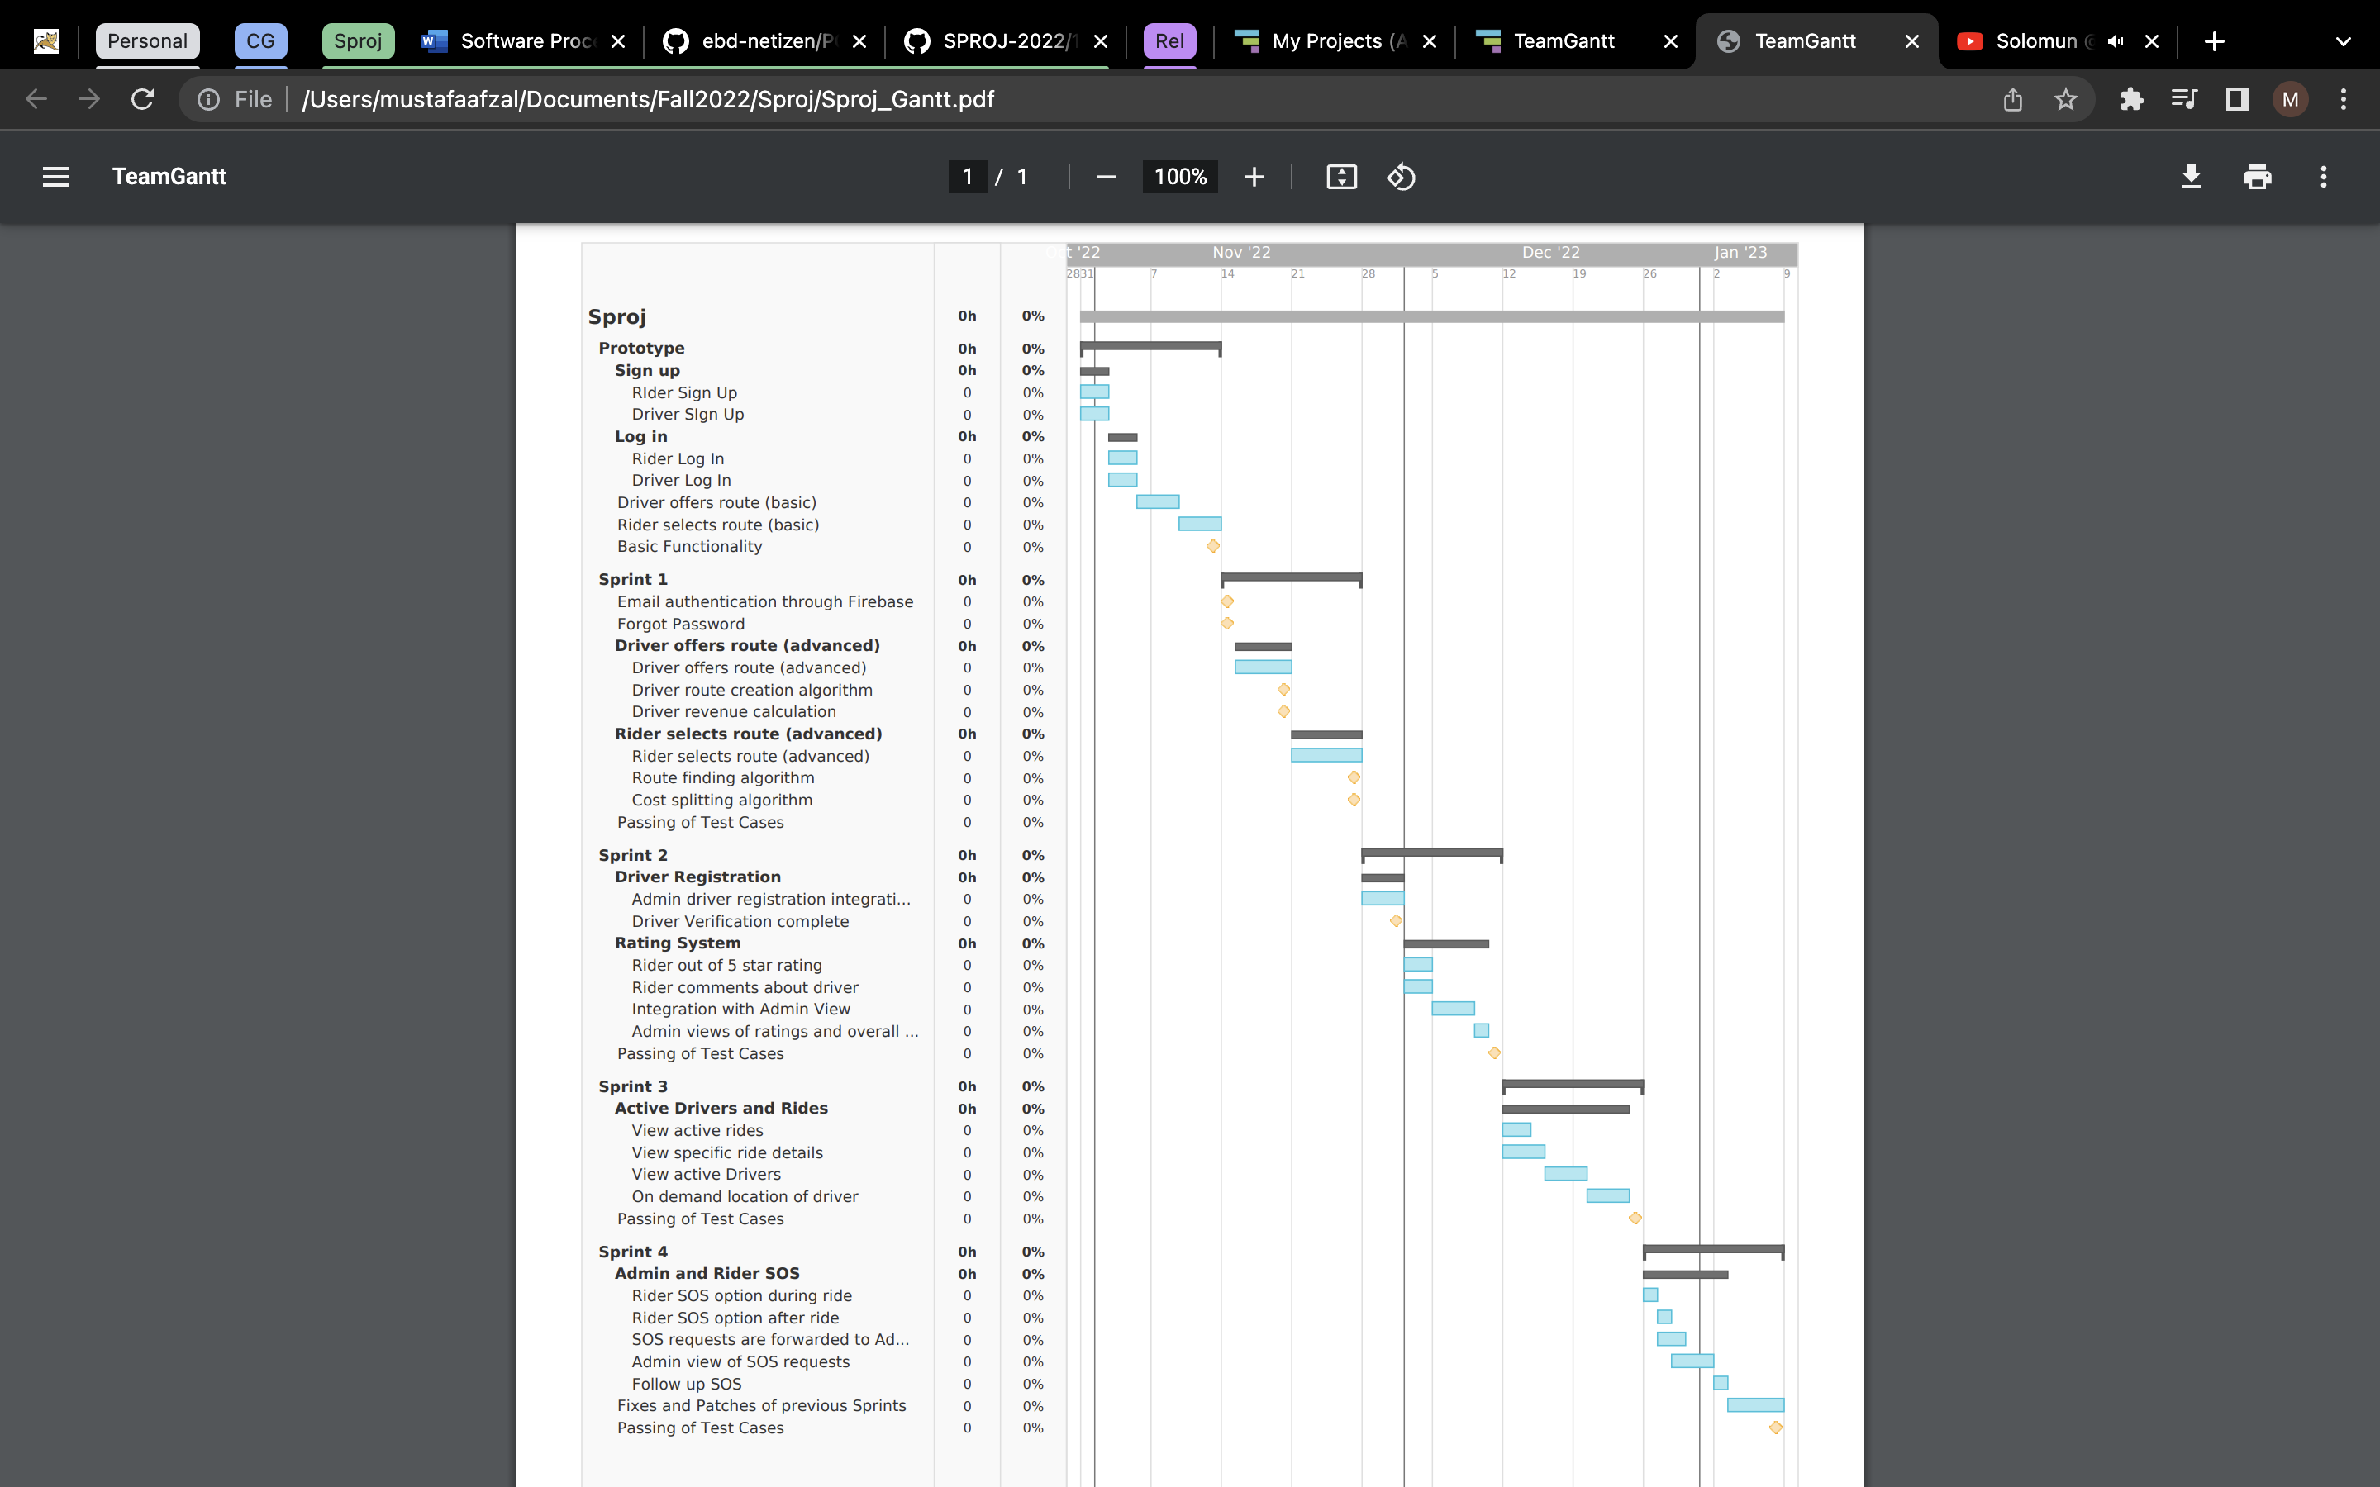

# Development Environment Preparation

The following tools will be used for our prototype development. The mentioned tools have already been installed and set up for our project.

**Flutter:**

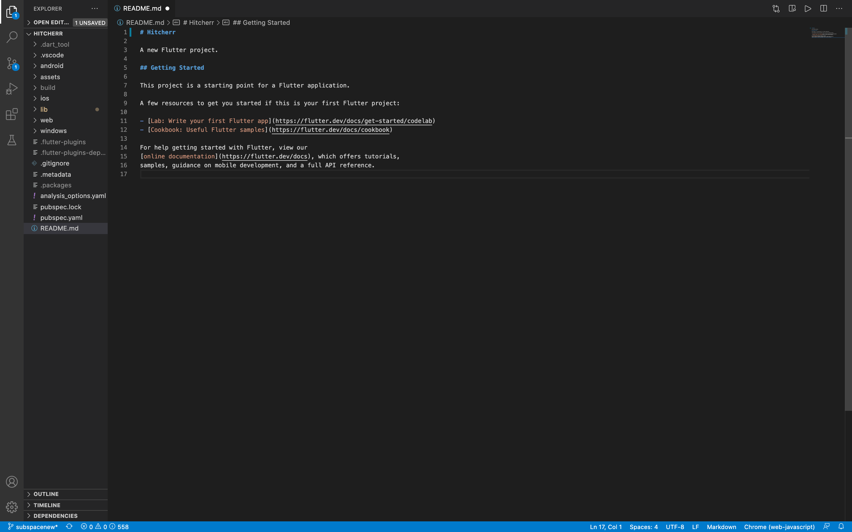

**Firebase:**

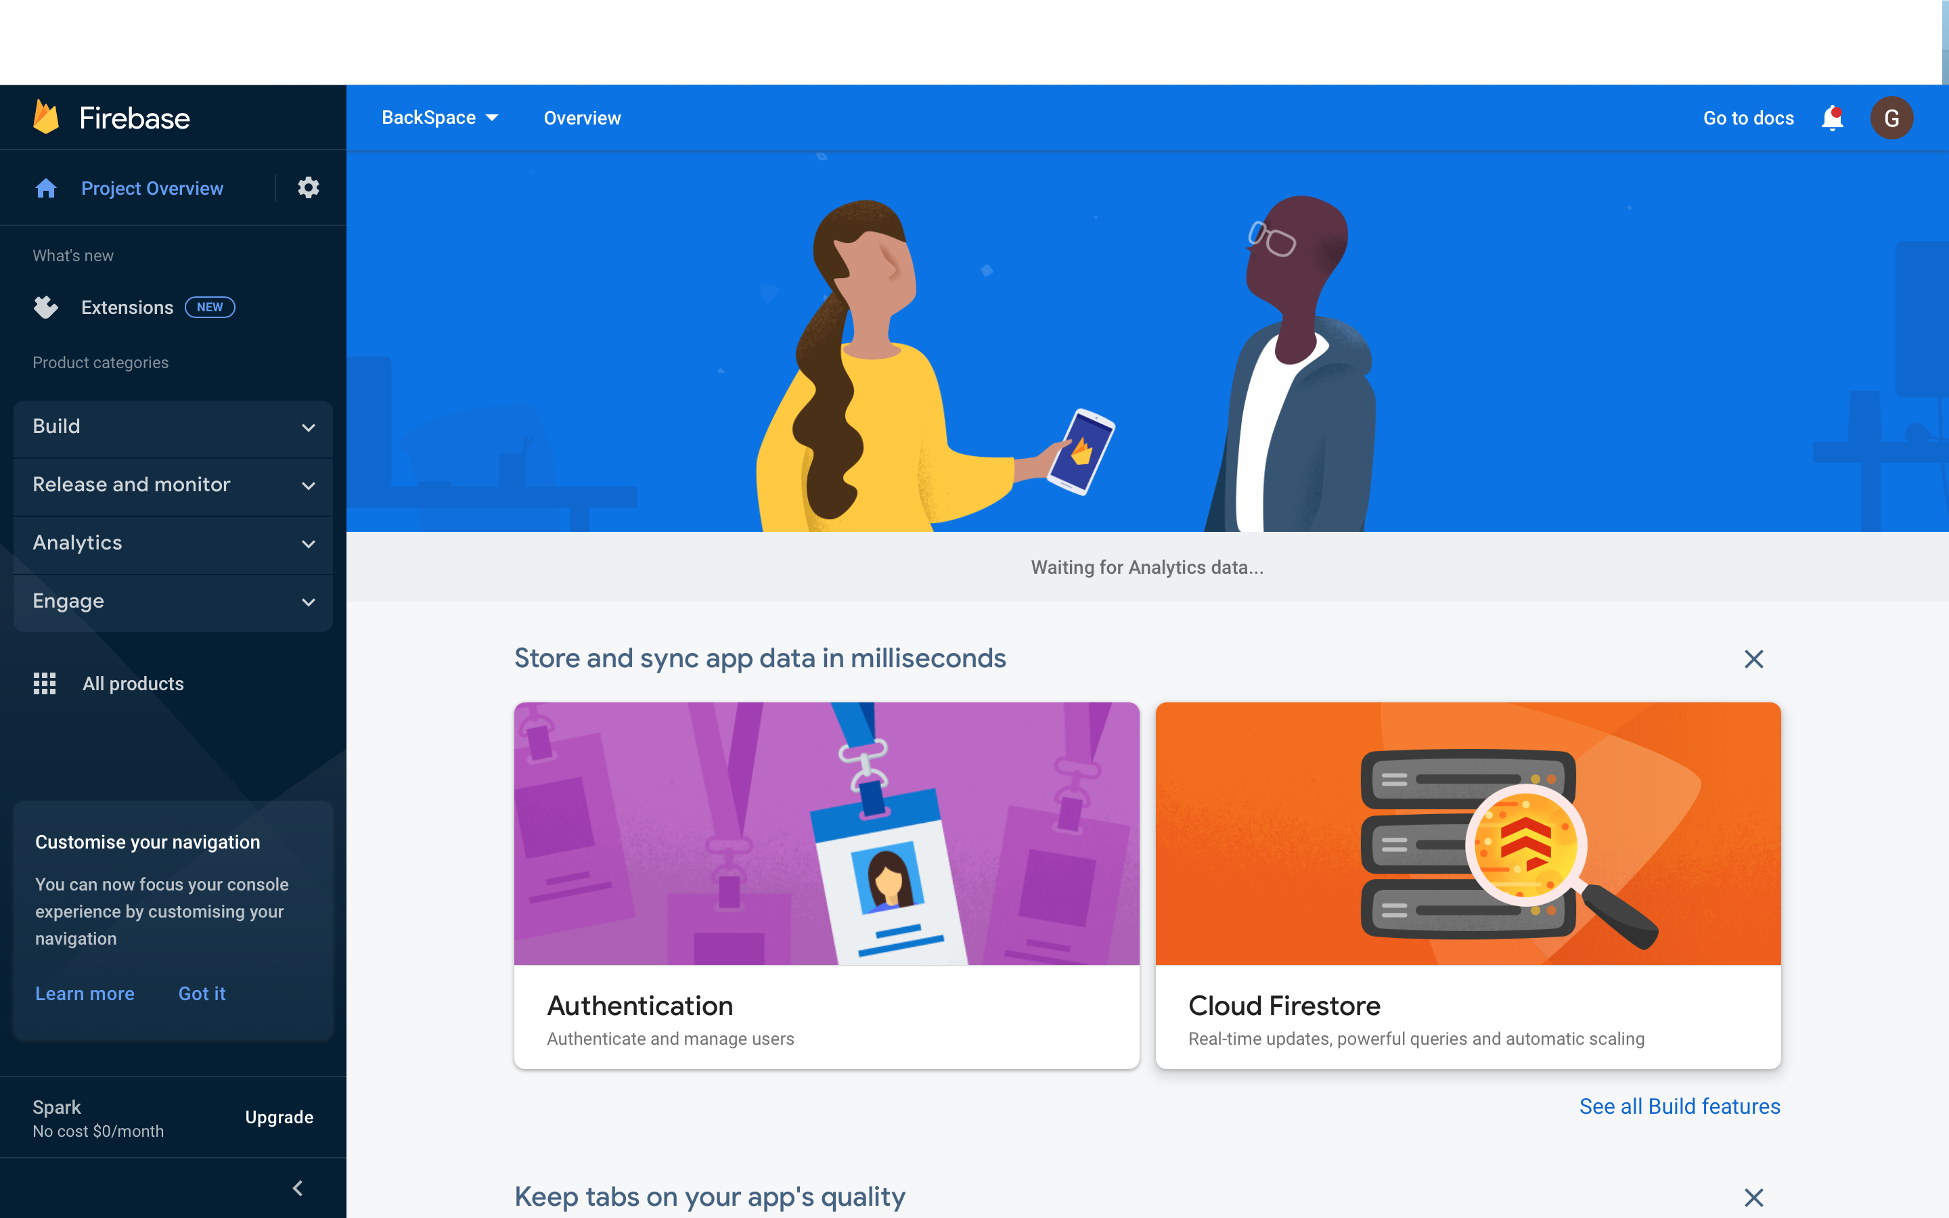

**Mongo:**

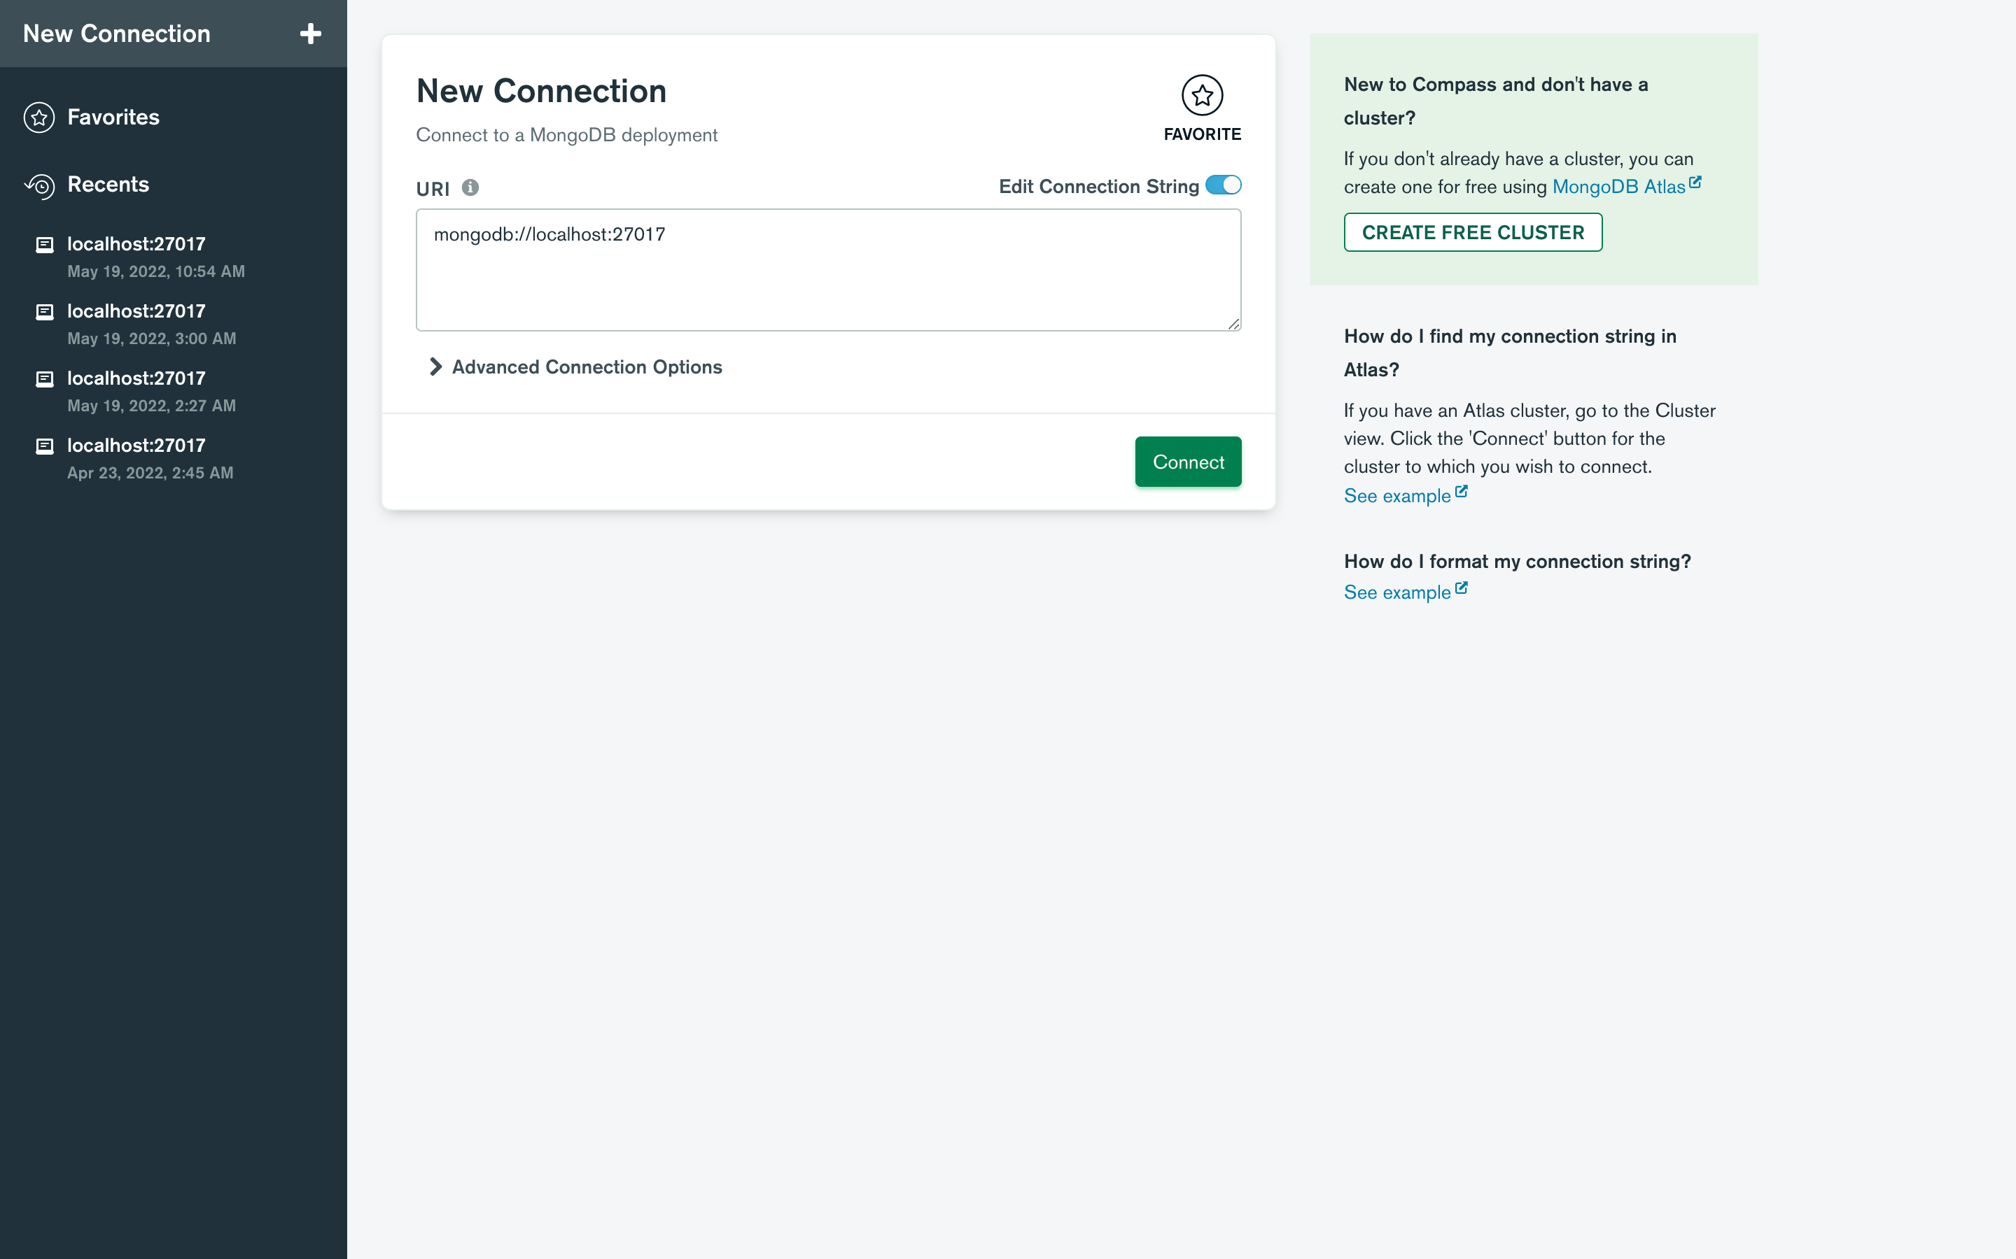

**React:**

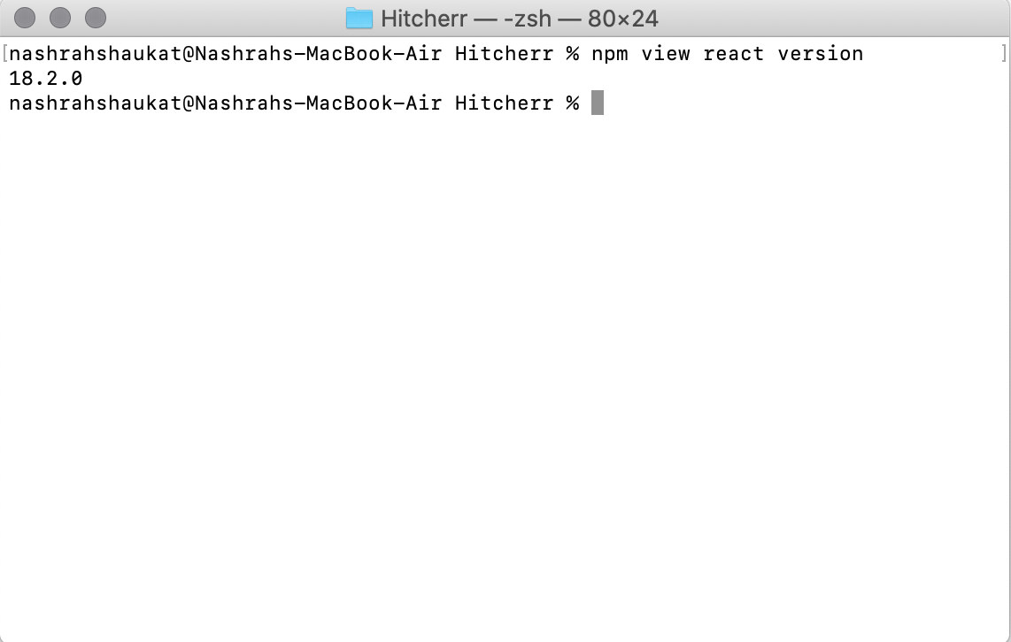

**Trello:**

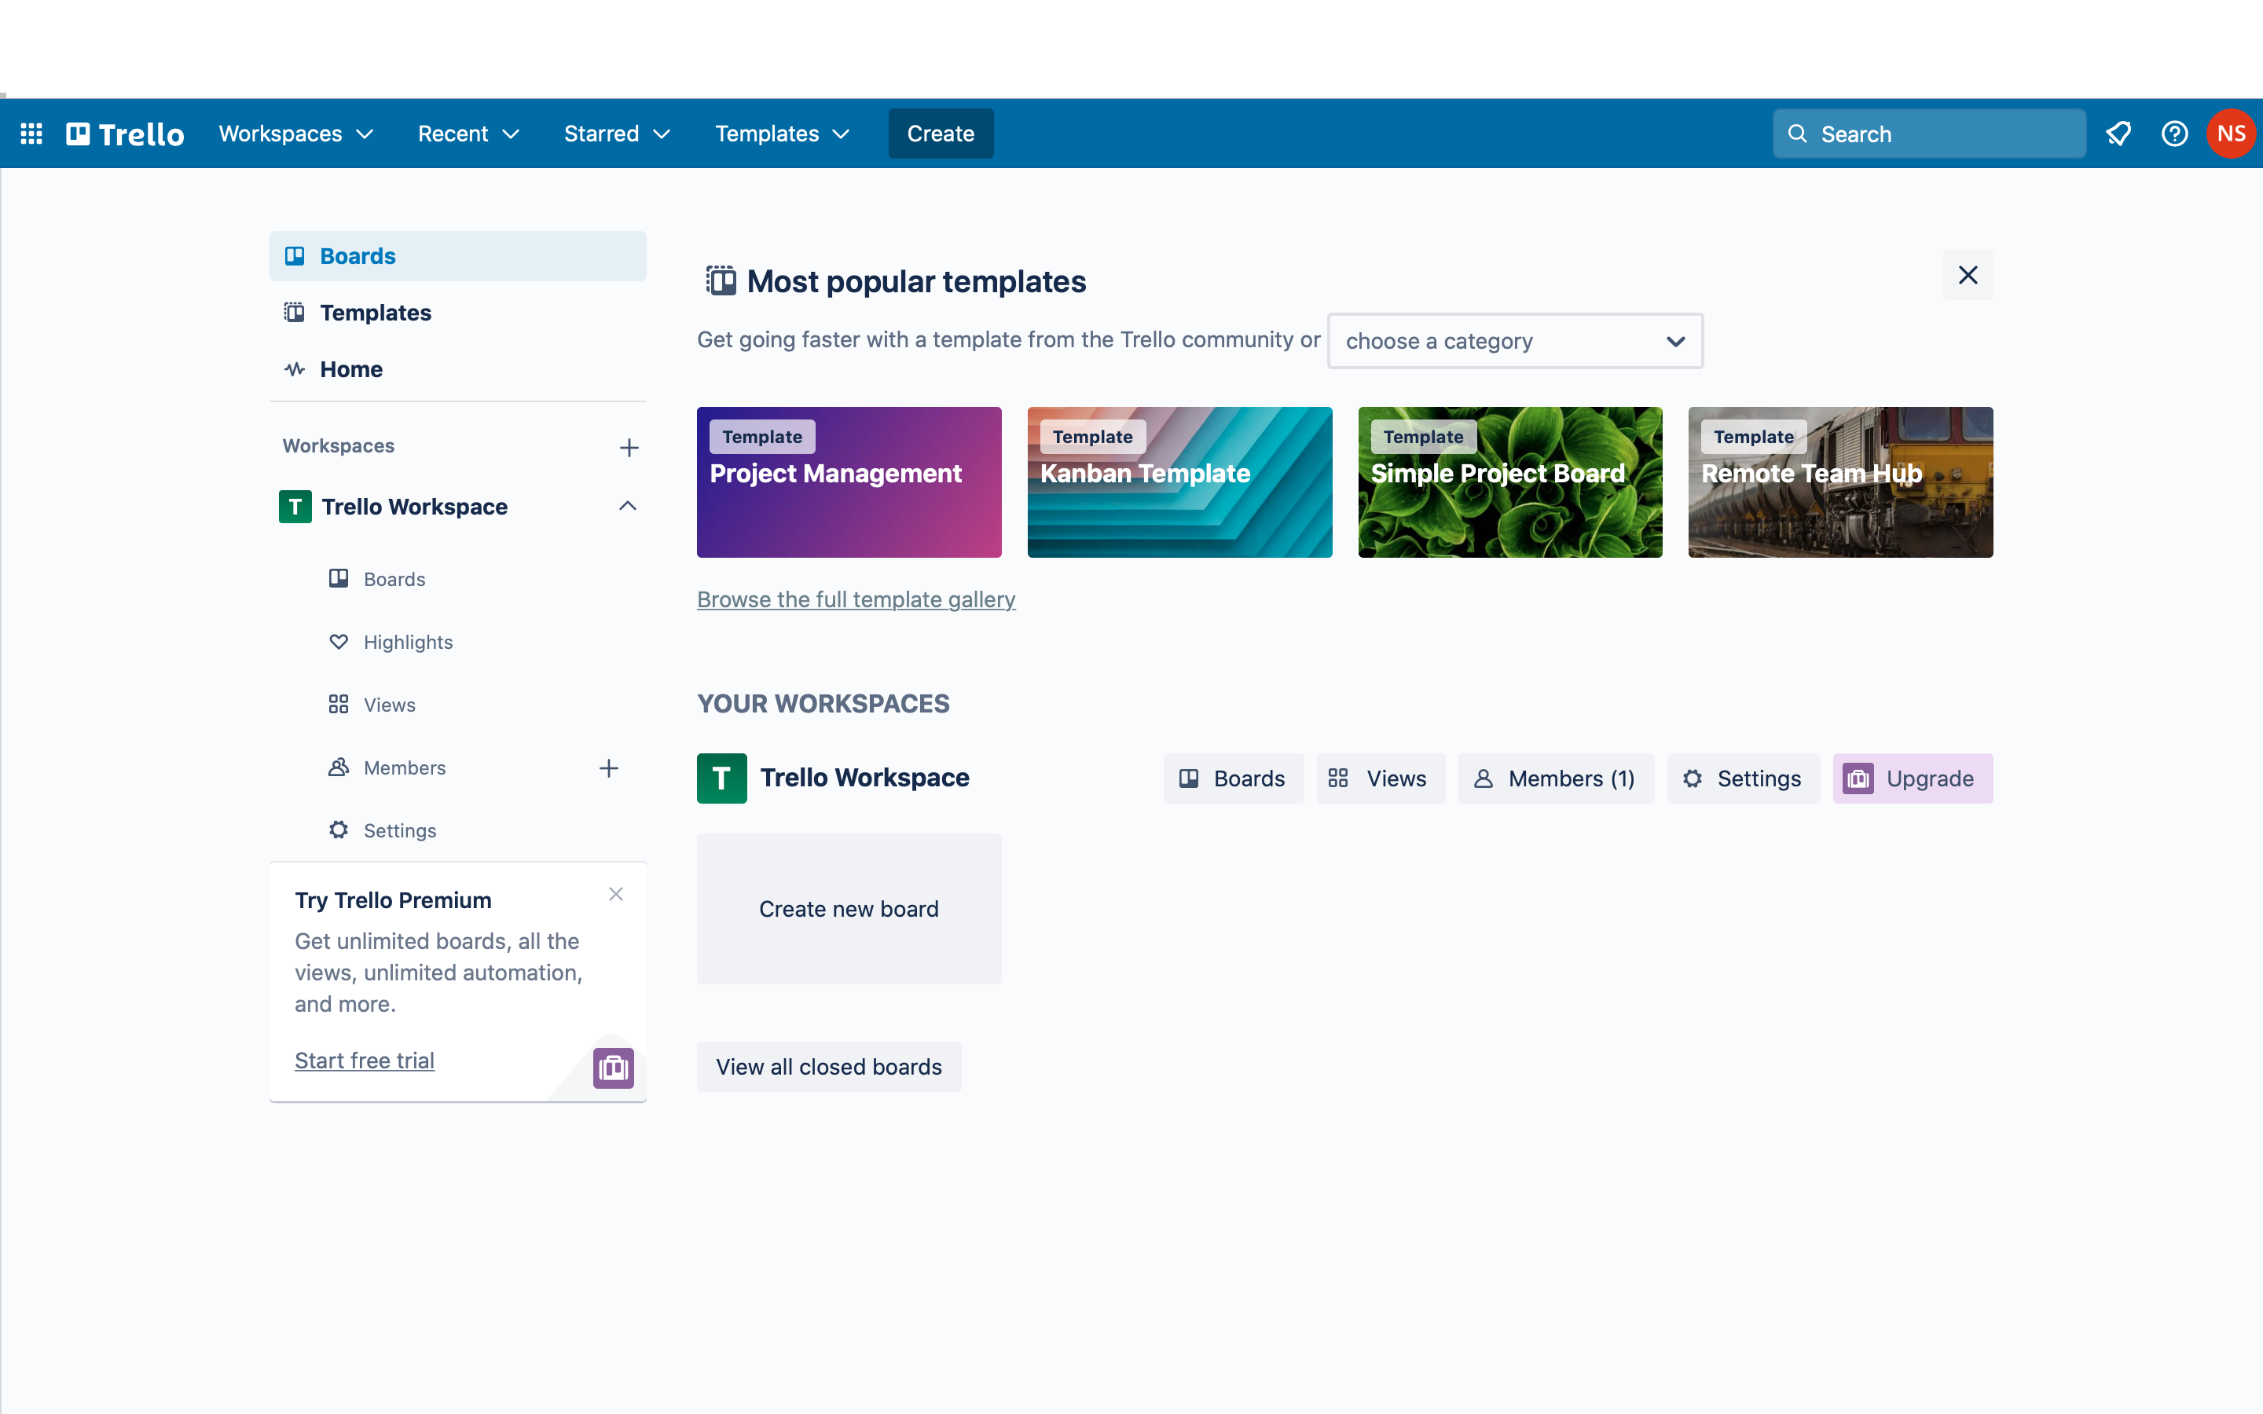

# Deployment Platform

We will be using Amazon Web Services (AWS) to deploy the web portion of our application.

Firebase will be used to deploy our mobile application.

# Who Did What?

|  |  |
| --- | --- |
| **Name of the Team Member** | **Tasks done** |
| Mustafa | Software Process Selection, Gantt Chart |
| Muneeb | Introduction, Deployment Platform, Gantt Chart |
| Nashrah | Development Environment Preparation |
| Ebad | Introduction, Software Process Selection |
| Irtza | Software Process Selection, Gantt Chart |

# Review checklist

Before submission of this deliverable, the team must perform an internal review. Each team member will review one or more sections of the deliverable.

|  |  |
| --- | --- |
| **Section** **Title** | **Reviewer Name(s)** |
| Introduction | Ebad |
| Software Process Selection | Irtza |
| Gantt Chart | Muneeb |
| Development Environment Preparation | Mustafa |
| Deployment Platform | Nashrah |